## Configuring the Road Markings

1. With the **Lane Mask** tool, mask out the broken line on the east west road across the intersection. (To make this clearer, we have drawn the lane mask in Black for this tutorial).

* 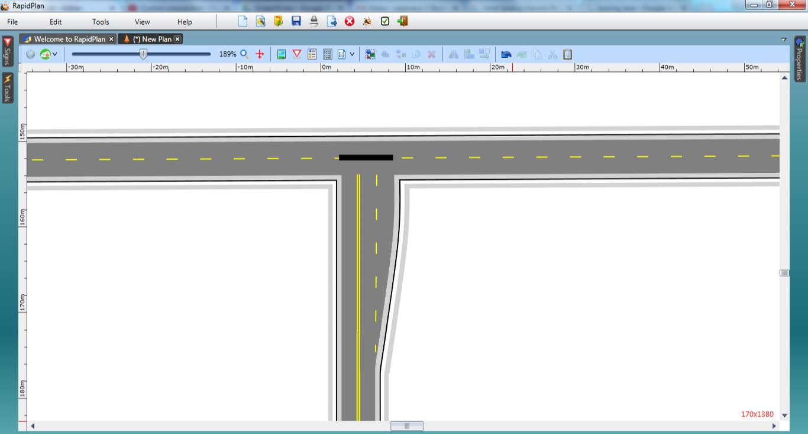
* T-intersection_Step_7